**CS PRACTIALS**

**Ex 1: Write a program to calculate the factorial of an integer**

**SOURCE CODE:**

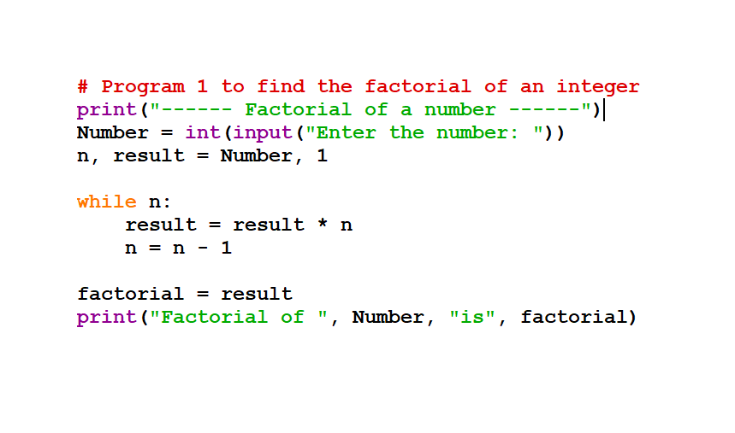

**INPUT/OUTPUT**

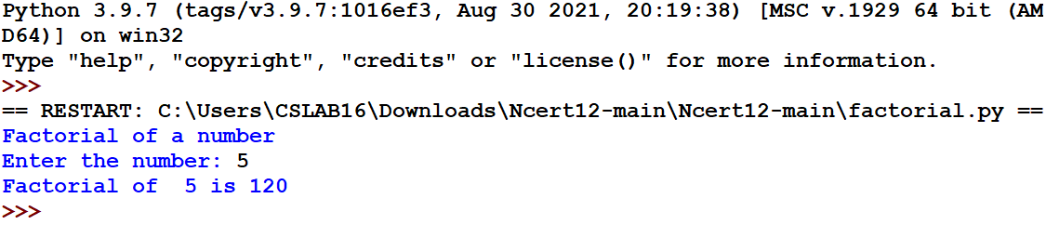

**Ex 2: Write a program to print Fibonacci series**

**SOURCE CODE:**

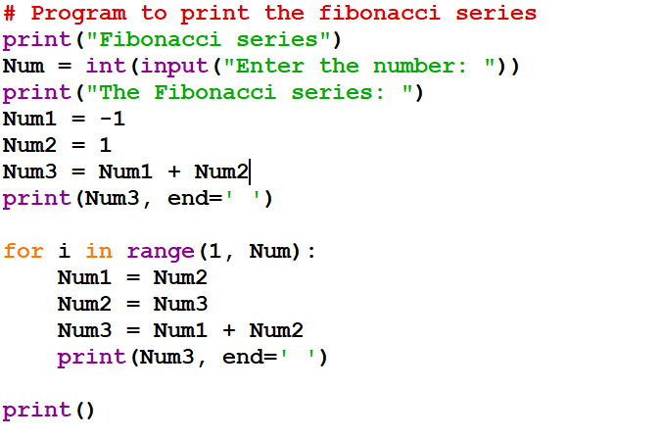

**INPUT/OUTPUT:**

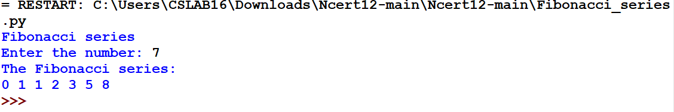

**EX 3: Write a python program to sum the sequence given below. Take the input n from the user: 1 + 1/1! + 1/2! + …. + 1/n!**

**SOURCE CODE:**

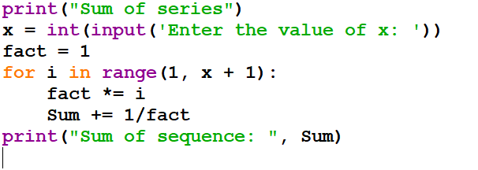

**INPUT/OUTPUT:**

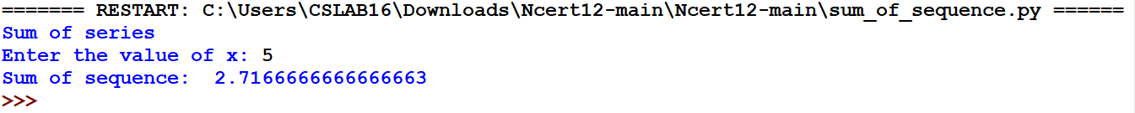

**EX 4: Write a python program for Linear Search**

**SOURCE CODE:**

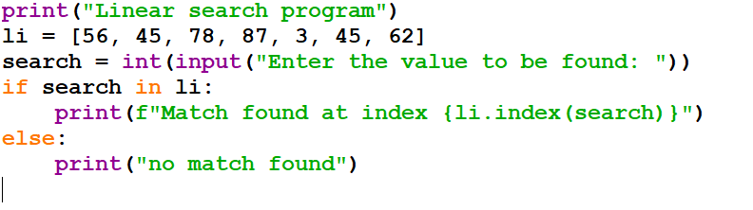

**INPUT/OUTPUT:**

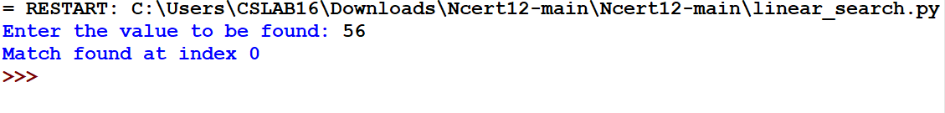

**EX 5: Write a program to check a number whether it is palindrome or not**

**SOURCE CODE:**

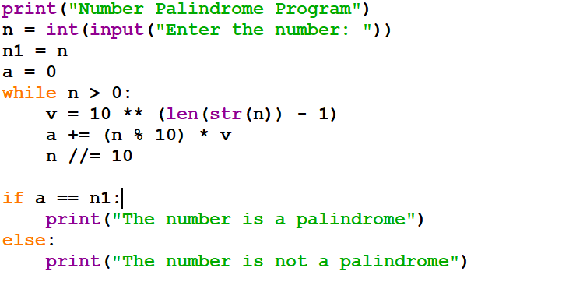

**INPUT/OUTPUT:**

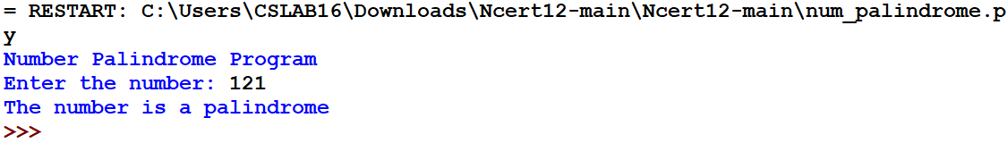

**EX 6: Write a program to read a text file line by line and display each word separated by ‘#’**

**SOURCE CODE:**

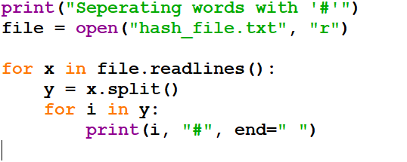

**INPUT/OUTPUT:**

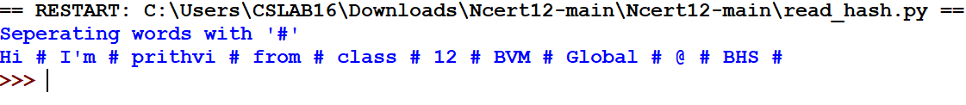

**EX 7: Create a binary file with name and roll number and display the data by reading the file**

**SOURCE CODE:**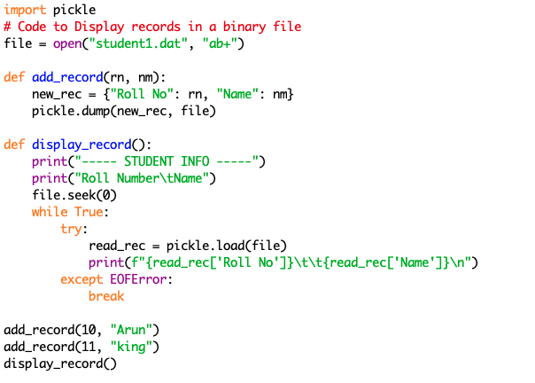

**INPUT/OUTPUT:**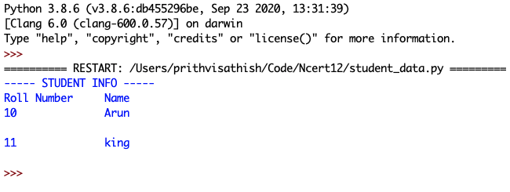

**EX 8: Create a binary file with name and roll number and search for a record with given roll number by reading the file**

**SOURCE CODE:**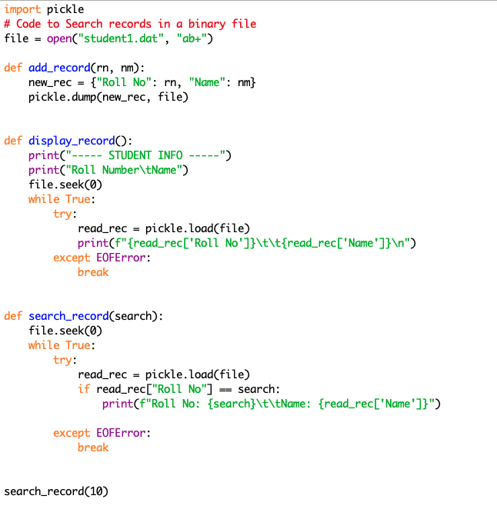

**INPUT/OUTPUT:**

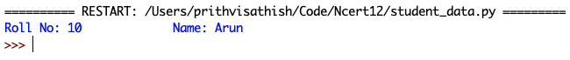

**Ex 9: Create a binary file with students name and roll number and update the name of a student by using the roll number**

**SOURCE CODE:**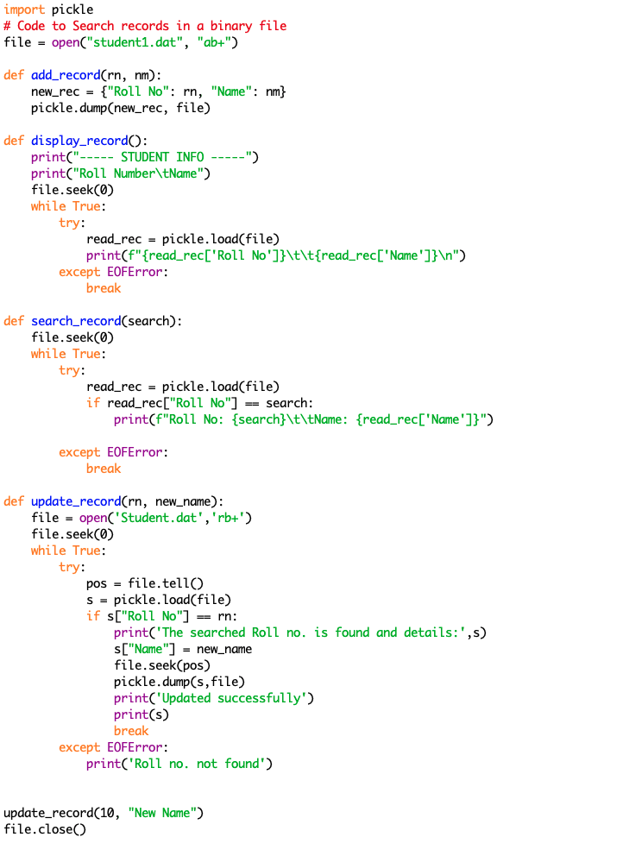

**INPUT/OUTPUT:**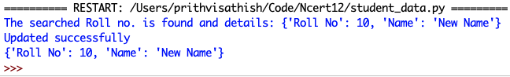

**Ex 10: Create a CSV file to store EmpNo, Name, Salary, and search any EmpNo and display Name and Salary**

**SOURCE CODE:**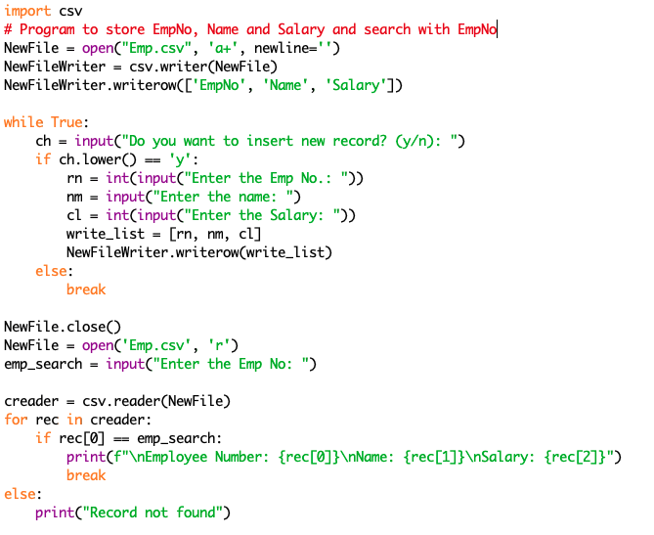

**INPUT/OUTPUT:**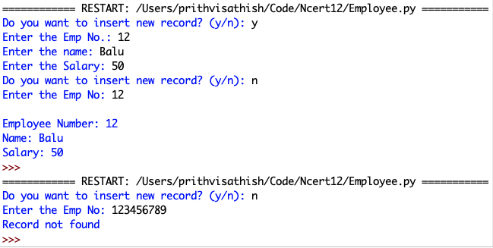

**Ex 11: Write a program to generate random numbers between 1 and 6 and check whether a given input wins a lottery or not**

**SOURCE CODE:**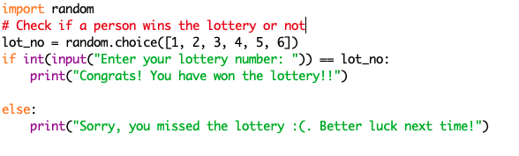

**INPUT/OUTPUT:**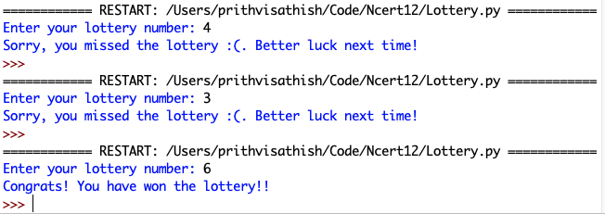

**Ex 12: Create a python program to create a user defined module and import the same in another module to calculate area and perimeter of shapes**

**SOURCE CODE:**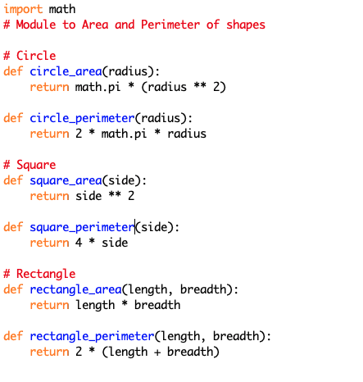

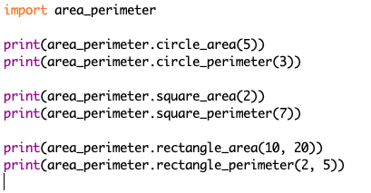

**INPUT/OUTPUT:**